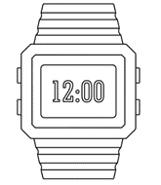

**PO3_DGW_Digital watch**

**(HSI)**

**DOCUMENT Status**

|  |  |  |  |
| --- | --- | --- | --- |
| **Version** | **Status** | **Author** | **Date** |
| 1.5 | Released | Basma Abdelhakim | 18/2/2020 |

**DOCUMENT History**

|  |  |  |  |  |
| --- | --- | --- | --- | --- |
| **Document name** | **Version** | **Description of Change** | **Author** | **Date of last update** |
| HSI document | 1.0 | - Initial creation of the document. | Basma Abdelhakim | 22/1/2020 |
| 1.1 | - Adding document status table.  - Listing all the needed hardware.  - Adding reference table. | Basma Abdelhakim | 31/1/2020 |
| 1.2 | -changing LCD specification.  -Updating HSI requirement table.  -changing reference table content.  -changing document status table content. | Basma Abdelhakim | 5/2/2020 |
| 1.3 | - Format Changed. | Ahmed Qandeel | 5/2/2020 |
| 1.4 | - Req_PO3_DGW_HSI_01_V01 requirement is edited | Ahmed Qandeel | 8/2/2020 |
| 1.5 | - Req_PO3_DGW_HSI_01_V01 requirement is divided into three requirements as follows:  - Req_PO3_DGW_HSI_01_V01.1.  - Req_PO3_DGW_HSI_02_V01.  - Req_PO3_DGW_HSI_03_V01.  -Changing Req_PO3_DGW_HSI_02_V01 ID to  Req_PO3_DGW_HSI_04_V01.  -Changing Req_PO3_DGW_HSI_03_V01 ID to  Req_PO3_DGW_HSI_05_V01.  -Adding section for hardware block diagram.  -Changing configuration of unused pins to input floating.  -Modifying reference table to correct format. | Basma Abdelhakim | 9/2/2020 |
| 1.5 | -Changing the document states to released. | Basma Abdelhakim | 18/2/2020 |

Table of contents

**1.Introduction 4**

1.1 Purpose 4

1.2 Hardware components 4

1.3 System block diagrams 4

1.4 Hardware components block diagrams 4

2.Pins description 6

3.Hardware software interface requirements 7

List of tables

**Table 2** HSI requirements 7

**Table 3** Reference document 7

List of figures

**Figure 1** General block diagram. 4

**Figure 2** Microcontroller Pins configuration. 4

**Figure 3** LMB161ALCD schematic. 5

# 1.Introduction

## 1.1 Purpose

This document identifies all the Hardware Software Interface (HSI) data that reference

a digital watch described in PO3_DGW_Digital watch(CRS) document.

## 1.2 Hardware components

1. AVR 8-bit Microcontroller with 32 Kbytes In-System Programmable Flash.

2. LMB161A Character LCD.

3. Tactical buttons.

4. Buzzer.

5.Power supply.

## 1.3 System block diagrams

liquid crystal display

Microcontroller

Button.1

# 

Buzzer

Button.2

Button.3

**Figure 1** General block diagram.

## 1.4 Hardware components block diagrams

# 

**Figure 2** Microcontroller Pins configuration.

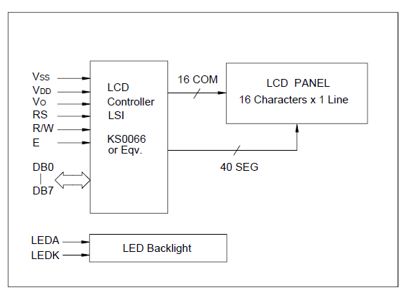

**Figure 3** LMB161ALCD schematic.

## 2.Pins description

|  |  |  |  |
| --- | --- | --- | --- |
| Pin No. | Symbol | Configuration | Function |
| 1 | PB0 | Input floating | Not used |
| 2 | PB1 | Input floating | Not used |
| 3 | PB2 | Input floating | Not used |
| 4 | PB3 | Input floating | Not used |
| 5 | PB4 | Input floating | Not used |
| 6 | PB5 | Input floating | Not used |
| 7 | PB6 | Input floating | Not used |
| 8 | PB7 | Input floating | Not used |
| 9 | RESET | Input floating | Not used |
| 10 | VCC | Digital supply voltage | This pin shall be connected to supply voltage. |
| 11 | GND | Ground | Ground |
| 12 | XTAL2 | Input floating | Not used |
| 13 | XTAL1 | Input floating | Not used |
| 14 | PD0 | Output | This pin shall be connected to LCD_RS. |
| 15 | PD1 | Output | This pin shall be connected to LCD_RW. |
| 16 | PD2 | Output | This pin shall be connected to LCD_E. |
| 17 | PD3 | Output | This pin shall be connected to buzzer. |
| 18 | PD4 | Input | This pin shall be connected to button 1. |
| 19 | PD5 | Input | This pin shall be connected to button 2. |
| 20 | PD6 | Input | This pin shall be connected to button 3. |
| 21 | PD7 | Input floating | Not used |
| 22 | PC0 | Input floating | Not used |
| 23 | PC1 | Input floating | Not used |
| 24 | PC2 | Input floating | Not used |
| 25 | PC3 | Input floating | Not used |
| 26 | PC4 | Input floating | Not used |
| 27 | PC5 | Input floating | Not used |
| 28 | PC6 | Input floating | Not used |
| 29 | PC7 | Input floating | Not used |
| 30 | AVCC | Input floating | Not used |
| 31 | GND | Input floating | Not used |
| 32 | AREF | Input floating | Not used |
| 33 | PA0 | Output | This pin shall be connected to LCD_D0. |
| 34 | PA1 | Output | This pin shall be connected to LCD_D1. |
| 35 | PA2 | Output | This pin shall be connected to LCD_D2. |
| 36 | PA3 | Output | This pin shall be connected to LCD_D3. |
| 37 | PA4 | Output | This pin shall be connected to LCD_D4. |
| 38 | PA5 | Output | This pin shall be connected to LCD_D5. |
| 39 | PA6 | Output | This pin shall be connected to LCD_D6. |
| 40 | PA7 | Output | This pin shall be connected to LCD_D7. |

## 3.Hardware software interface requirements

**Table 2** HSI requirements

|  |  |
| --- | --- |
| **HSI requirement** | **Requirement description** |
| Req_PO3_DGW_HSI_01_V01.1 | The tactical switches shall be used to switch between the three modes of the digital watch as follows.  Button 1 shall be used to select clock mode. |
| Req_PO3_DGW_HSI_02_V01 | Button 2 shall be used to select alarm mode, and when selected it shall be used to set alarm time. |
| Req_PO3_DGW_HSI_03_V01 | Button 3 shall be used to select stopwatch mode, and when selected it shall be used to stop and reset counting respectively. |
| Req_PO3_DGW_ HSI_04_V01 | The active buzzer shall be used to notify the user when the alarm’s time hit. |
| Req_PO3_DGW_ HSI_05_V01 | The LCD displayer shall be used to display the chosen mode interface according to the user’s choice. |

**Table 3** Reference document

|  |  |  |
| --- | --- | --- |
| **Reference document** | **version** | **status** |
| PO3_DGW_Digital watch_CRS | ----------------------- | ----------------------- |